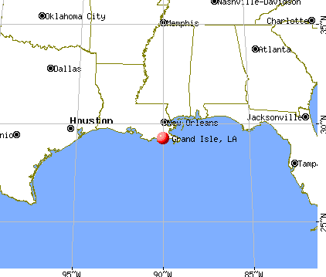
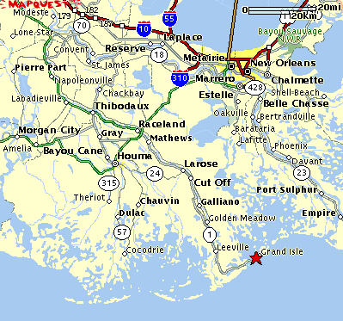
Grande Isle
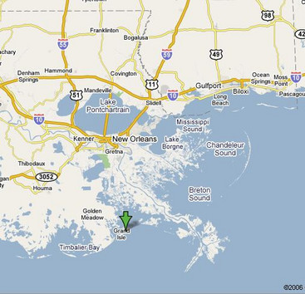
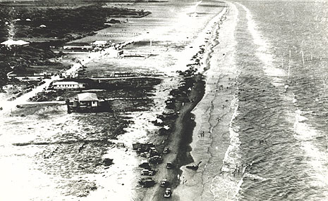
EARLY SETTLEMENT
Prior to European settlement Grand Isle was frequented by the Chitimacha, one of the Houma Indian tribes.
Louisiana was under Spanish rule for forty years from 1762 to 1801. From 1781 to 1787 four royal land grants were given to families eager to develop Grand Isle. James Rigaud of Bordeaux, France received the largest grant of 120 arpents on the eastern end of the island from Governor Galvez. The Rigauds were active and prosperous landowners – and Bayou Rigaud on the bay side of the island is named for them. Descendents of the Rigauds still live on the island.
Central Grand Isle was divided into two grants between 1782 and 1785. A portion of the western end of the island was given to Joseph Caillet. He passed away shortly after and his wife sold the property to Manual Encalada, a Baratarian. It is believed the original Encaladas came from Spain. In the middle of the island, between Caillet and the Rigaud grant was property owned by Francois Anfrey, an absentee landlord who raised a few cattle there. When he passed away around 1813, his daughter sold the property to Pierre St. Amand who then sold it to Louis Chighizola, one of Jean Lafitte’s men 1818. And in 1787 the last portion of the available land on the island went to Charles Dufrese.
Residents on the island raised crops, cattle, horses, and fished and hunted. As today, they swam in the surf and walked the beaches searching for driftwood, and treasures from ships. Agriculture was one of the early mainstays of the island’s economy. Crops such as sugar cane, cotton and cucumbers were grown here. And of course the island was well known for production of shrimp, oysters, a wide variety of fish, and turtles.
The Grand Isle Area also had pirates. The infamous Jean Lafitte arrived around 1805. From his point of view he was a “privateer” not a pirate, and the government recognized the difference – mostly. For example, the goods he managed to accumulate were taxed and regulated by the government. A colorful legend he used Grand Terre, the island just east of Grand Isle as his base of operations.
Mid-1800’s to the mid-1900’s
Landowners developed large plantations in the center of Grand Isle. One, Barataria Plantation, was two mile long, had about 100 slaves and a variety of buildings (carpenter, blacksmith, slave hospital, sugar house, etc.). The Plantation years ended during the Civil War, sugar cane declined and cotton became a major crop. In the middle 1800’s wealthy families from other parts of Louisiana began spending several months at the sea shore. Isle Derniere, west of Grand Isle was one of the most popular resorts. After 1860 much of the plantation was sold to Joseph Harvey, developer of the Harvey Canal in New Orleans. He remodeled many of the slave cabins to become cottages and used the plantation house as a hotel, the “Grand Isle Hotel.” Railroad tracks laid from the hotel to the beach transported vacationers via railroad cars pulled by mule. In 1888 P. F. Herwig began construction of a large, elegant, plantation-style building that became the Ocean Club Hotel. This hotel had 160 suites, two dining halls, tennis courts, a bowling alley and sixty bathhouses. Completed in 1892, the Hotel had one season of use before the Hurricane of 1893 devastated neighboring Chenier (just west of Grand Isle) and caused great damage to Grand Isle as well. Tourism was put on hold.
In 1882 Father D’Espinsoa arrived on Grand Isle to establish a church. He was surprised when they suggested he go to neighboring Cheniere. He build a chapel there and had a magnificent bell cast from gold and silver, a bell that weighed 700 lbs. He was succeeded by Father Grimeaux who lived on Cheniere for three years before the hurricane of 1983 struck with tidal surges of 20 feet and higher. It is said that the church bell tolled all night long the night of October 1, but the bell tower eventually fell and the bell recovered by survivors. After that the bell, called the Bell of Caminada, disappeared despite requests from a number of new churches. And just as suddenly twenty-five years later while preparing the dedication of a Grand Isle chapel the bell reappeared as an offering for the new chapel. A bell tower was constructed for the bell in 1961 and it is in use at Our Lady of the Isle Church.
From the eastern edge of Grand Isle you can see Fort Livingston on the westernmost tip of Grand Terre, a neighboring island. The construction of this massive fort began in the 1830’s. The government bought a tract of land from Etienne De Gruy on the west end of Grand Terre Island in 1834 and began the construction of the Fort. But construction was suspended in July of that year. Work resumed in 1840 and construction on the fort itself began in 1841. Although much was constructed, the Fort was never completed. It was occupied by Confederate soldiers during the Civil War and its guns were dismounted in 1872. It was returned to the state in 1923. Since 1955 Grand Terre has been a state Wildlife and Fisheries reservation, and in 1979 the Louisiana legislature created the Fort Livingston State Commemorative Area.
Hurricanes
Hurricane Katrina struck Grand Isle a significant, yet glancing blow, on August 29, 2005. A tidal surge of six to ten feet crossed the island from the bay side, sweeping away or drastically affecting residences, camps (particularly the lower parts of camps), and businesses. Not only were buildings damaged but boats washed in to the middle of the island and the debris field created by the tidal surge was enormous. Some parts of Grand Isle wound up on the shores of Texas. Recovery was slow and painful. And then it looked as though Hurricane Rita which followed Katrina by a short month might also hit Grand Isle – but it was a smaller, glancing blow that pushed one to three feet of tidal surge from the Gulf of Mexico across the island. The end result was more damage and more debris.
— http://www.friendsofgrandisle.com/historyof-grand-isler.html

